**OBJECTIVES:**

In this lab we learnt about

* Implementing and performing basic operations on Hash Table data structure.

**11.2.1 Hash Table** Hash Table is a data structure which stores data in an associative manner. In a hash table, data is stored in an array format, where each data value has its own unique index value. Access of data becomes very fast if we know the index of the desired data.  
Thus, it becomes a data structure in which insertion and search operations are very fast irrespective of the size of the data. Hash Table uses an array as a storage medium and uses hash technique to generate an index where an element is to be inserted or is to be located from.  
  
**11.2.2 Hash Function** In simple terms, a hash function maps a big number or string to a small integer that can be used as index in hash table.  
A good hash function should have following properties  
 1) Efficiently computable.  
 2) Should uniformly distribute the keys (Each table position equally likely for each key)  
For example for phone numbers a bad hash function is to take first three digits. A better function is consider last three digits. Please note that this may not be the best hash function. There may be better ways.

**11.2.3 Collision Handling**

* **Chaining:** The idea is to make each cell of hash table point to a linked list of records that have same hash function value. Chaining is simple, but requires additional memory outside the table.  
  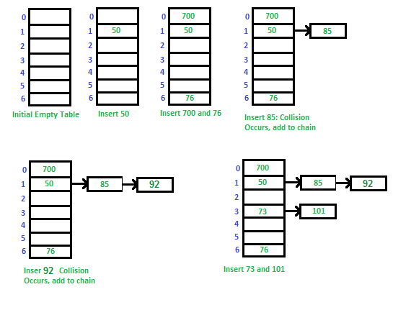
* **Open Addressing:** In open addressing, all elements are stored in the hash table itself. Each table entry contains either a record or NIL. When searching for an element, we one by one examine table slots until the desired element is found or it is clear that the element is not in the table.

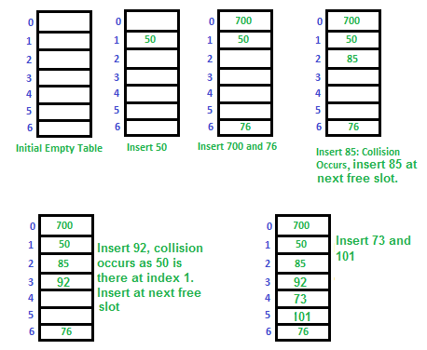

**LAB TASKS:**

**TASK 1:**

Implement hash table with following operations

a) Hashing

b) Insertion

c) Deletion

d) Searching

e) Rehashing

**CODE:**

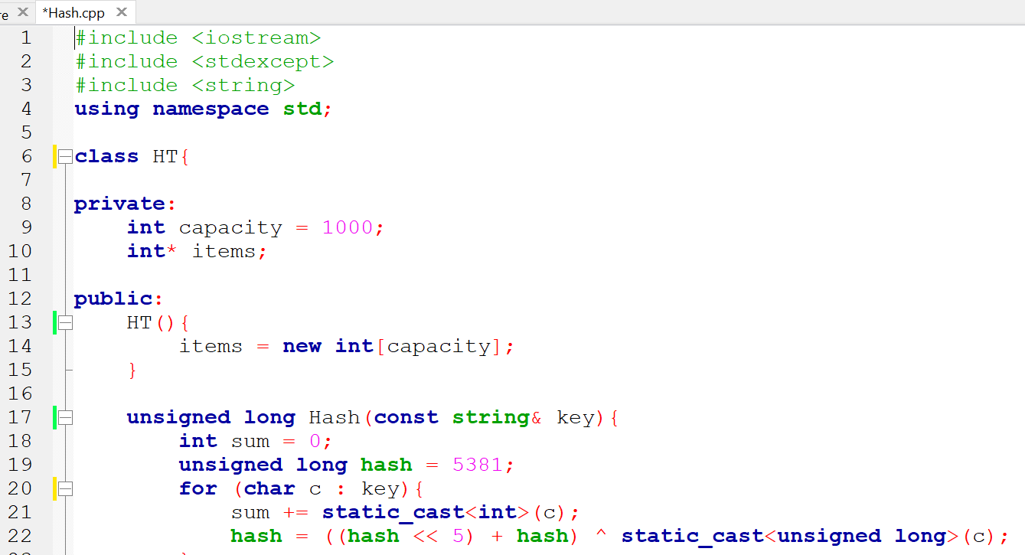

**OUTPUT:**

